

**GAME 2023 GAME ENGINE II**

**Lab 7**

**DESCRIPTION:**

In this lab, we will be making use of RPCs and replication to create a networked chat.

**REQUIREMENTS:**

1. Start with any project template, including empty (Blueprints or C++; your choice)
2. Create a UI using UMG to allow the player to enter a message.  
   This UI will serve previous chat messages and allow the player to enter a new message.
   1. One possible solution is the following:  
      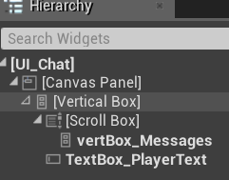  
      - The textbox is given keyboard focus to allow the player to enter text (SetKeyboardFocus)  
      - On Text Committed of your text box (Method: OnEnter), send the message to the server and clear the text box  
      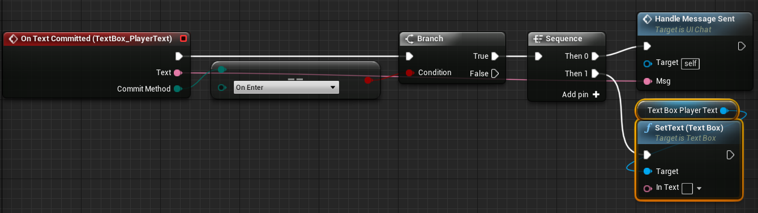  
      - Logged messages are populated dynamically in the vertBox_Messages when the list changes (ie. OnRep)
3. When the user enters a message, use an RPC to send that message to the server.
4. The server will validate that the message does not contain the words “fuddle duddle” (use FString::Contains with ESearchCase::IgnoreCase as the second parameter).
5. A replicated array of FString messages contains all messages received by the server.
6. The array of messages is displayed on all clients.

**DUE DATE:**

Before the next lecture starts.

**DELIVERABLES:**

None; Show me in the next class when I come around to you.

**RECOMMENDED: REGULAR SOURCE CONTROL BACKUPS**

***IMPORTANT! READ THIS CAREFULLY. Be sure you’re not including large and unnecessary directories.***

|  |
| --- |
| **\*\*\*\*\*\*\*\*\*\*\*\*\*\*\*\*\*\*\*\*\*\*\*\*\*\*\*\*\*\*\*\*\*\*\*\*\*\*\*\*\*\*\*\*\*\*\*\*\*\*\*\*\*\*\*\*\*\*\*\*\*\*\*\*\*\*\*\*\*\***  **IF submitting a C++ Project (not applicable to Blueprint only projects):**  **Close the editor and re-compile your project in visual studio**  **To clear out hot-reload dlls and to make the project usable without needing to recompile.**  **\*\*\*\*\*\*\*\*\*\*\*\*\*\*\*\*\*\*\*\*\*\*\*\*\*\*\*\*\*\*\*\*\*\*\*\*\*\*\*\*\*\*\*\*\*\*\*\*\*\*\*\*\*\*\*\*\*\*\*\*\*\*\*\*\*\*\*\*\*\*** |

In P4V, mark **ONLY** the following files and folders for add:

* The .**uproject**
* The **Content directory**
  + Not the StarterContent directory
* The **Config directory**
* The **Source directory** *(if there is one)*
* Binaries/Win64/UE4Editor.modules *(if available)*
* Binaries/Win64/UE4Editor-ProjectName.dll *(if available)*

Submit the marked files and write a changelist description.

|  |
| --- |
| **\*\*\*\*\*\*\*\*\*\*\*\*\*\*\*\*\*\*\*\*\*\*\*\*\*\*\*\*\*\*\*\*\*\*\*\*\*\*\*\*\*\*\*\*\*\*\*\*\*\*\*\*\*\*\*\*\*\*\*\*\*\*\*\*\*\*\*\*\*\***  **DO NOT Submit the following:**   * **.vs** folder * **intermediate** folder * **binary** folder content, other than the two files listed above * **saved** folder   **\*\*\*\*\*\*\*\*\*\*\*\*\*\*\*\*\*\*\*\*\*\*\*\*\*\*\*\*\*\*\*\*\*\*\*\*\*\*\*\*\*\*\*\*\*\*\*\*\*\*\*\*\*\*\*\*\*\*\*\*\*\*\*\*\*\*\*\*\*\*** |